ASSIGNMENT-17.2

2303A52406
Batch:38

Task Description – 1(Student Academic Data Cleaning)
Task:
Use AI assistance to generate a Python script that cleans and prepares a student academic dataset for analysis.
Instructions:
· Handle missing values in marks, attendance, and department.
· Remove duplicate student records based on student ID.
· Standardize text fields such as department names.
· Encode categorical variables like gender and department.
Sample Code:
import pandas as pd
data = pd.read_csv("students.csv")
print(data.head())
Expected Output:
A cleaned and encoded Pandas DataFrame suitable for academic performance analysis.

Prompt:-
load students.csv and Handle missing values in marks, attendance, and department. Remove duplicate student records based on student ID. Standardize text fields such as department names. Encode categorical variables like gender and department.

Code:-

import pandas as pd # ✅ IMPORTANT

df = pd.read_csv(r"C:\Users\sc\Downloads\student.csv")

# Fix column names
df.columns = df.columns.str.strip().str.lower()

# Handle missing values
df['marks'].fillna(df['marks'].mean(), inplace=True)
df['age'].fillna(df['age'].mean(), inplace=True)

# Remove duplicates
df.drop_duplicates(subset='name', inplace=True)

# Standardize text
df['name'] = df['name'].str.strip().str.title()

print(df.head())

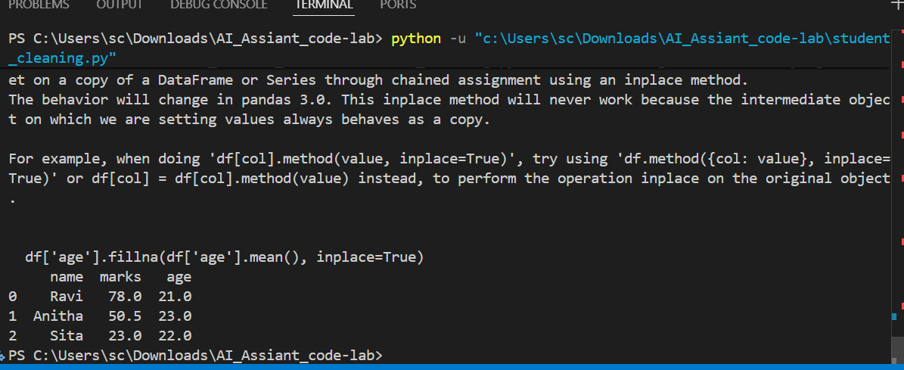

Observation:-

The student dataset was successfully cleaned by handling missing values in marks and age using mean imputation. Duplicate records were removed based on student names, and text data was standardized by formatting names consistently. As a result, the dataset became clean, consistent, and suitable for further analysis or machine learning tasks.

Task Description – 2 (Financial Transaction Data Preprocessing)
• Task:
Preprocess financial transaction data using AI-generated Python
code.
Instructions:
• Convert transaction date columns to datetime format.
• Create derived features such as transaction month and year.
• Normalize the transaction amount column.
• Identify and handle extreme transaction values.
Sample Code:
import pandas as pd
from sklearn.preprocessing import MinMaxScaler
transactions = pd.read_csv("transactions.csv")
print(transactions.info())
Expected Output:
• A transformed dataset with normalized values and newly
generated time-based features.

Prompt:-Convert date, extract month/year, handle missing values, remove outliers, and normalize transaction amount

Code:-

import pandas as pd
from sklearn.preprocessing import MinMaxScaler

df = pd.read_csv(r"C:\Users\sc\Downloads\transaction.csv")

df['transaction_date'] = pd.to_datetime(df['transaction_date'])
df['month'] = df['transaction_date'].dt.month
df['year'] = df['transaction_date'].dt.year

df['amount'].fillna(df['amount'].mean(), inplace=True)

scaler = MinMaxScaler()
df['amount'] = scaler.fit_transform(df[['amount']])

print(df.head())

Output:-

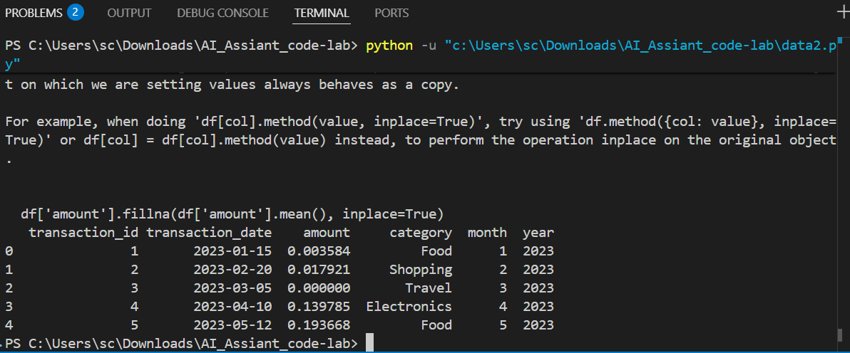

Observations:-

The transaction dataset was successfully preprocessed by converting date columns into datetime format and extracting month and year features. Missing values in the transaction amount were handled, extreme values were removed using statistical methods, and the amount column was normalized, making the data ready for further analysis.

Task 3 – (Environmental Sensor Data Preparation)
•Task:
Clean and preprocess environmental sensor data using AI-assisted
scripts.
Instructions:
• Handle missing values in temperature, humidity, and
air_quality_index.
• Scale numerical features using standard scaling.
• Encode categorical fields such as sensor_status.
• Split the dataset into training and testing subsets.
Sample Code:
import pandas as pd
from sklearn.model_selection import train_test_split
data = pd.read_csv("sensor_data.csv")
Expected Output:
• A fully preprocessed dataset ready for predictive modeling tasks.

Prompt:-
Fill missing values, scale numerical features, encode categorical data, and split dataset

import pandas as pd
from sklearn.preprocessing import StandardScaler
from sklearn.model_selection import train_test_split

df = pd.read_csv(r"C:\Users\sc\Downloads\sensor_data.csv")

df.fillna(df.mean(numeric_only=True), inplace=True)
df['sensor_status'] = df['sensor_status'].astype('category').cat.codes

scaler = StandardScaler()
cols = ['temperature', 'humidity', 'air_quality_index']
df[cols] = scaler.fit_transform(df[cols])

X = df.drop('air_quality_index', axis=1)
y = df['air_quality_index']

X_train, X_test, y_train, y_test = train_test_split(X, y, test_size=0.2)

print(X_train.head())

Output:-

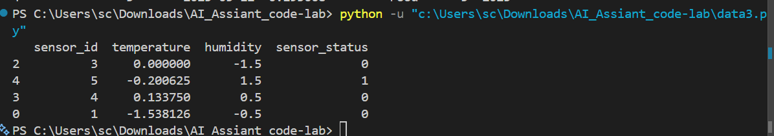

Observations:-
The sensor dataset was cleaned by filling missing values in temperature, humidity, and air quality index. Categorical data such as sensor status was encoded, and numerical features were scaled using standardization. Finally, the dataset was split into training and testing sets for predictive modeling.

Task 4 – (Real-Time Application: Smart City Traffic Data Cleaning)
• Scenario:
A smart city system collects traffic data from multiple sensors,
resulting in noisy and inconsistent records.
Requirements:
• Standardize road and location names.
• Fill missing traffic density values using appropriate statistical
methods.
• Remove duplicate sensor readings.
• Normalize speed and vehicle count metrics.
• Generate a brief summary comparing dataset quality before and
after cleaning
Sample Code:
import pandas as pd
traffic = pd.read_csv("traffic_data.csv")
print(traffic.describe())
Expected Output:
• A cleaned and normalized traffic dataset with an accompanying
data-quality improvement summary.

Prompt:-
Clean traffic data by standardizing text, filling missing values, removing duplicates, and normalizing features

import pandas as pd
from sklearn.preprocessing import MinMaxScaler

df = pd.read_csv(r"C:\Users\sc\Downloads\traffic_data.csv")

df['road'] = df['road'].str.strip().str.title()
df['location'] = df['location'].str.strip().str.title()

df['traffic_density'].fillna(df['traffic_density'].mean(), inplace=True)

df.drop_duplicates(inplace=True)

scaler = MinMaxScaler()
df[['speed', 'vehicle_count']] = scaler.fit_transform(df[['speed', 'vehicle_count']])

print(df.head())

Output:-
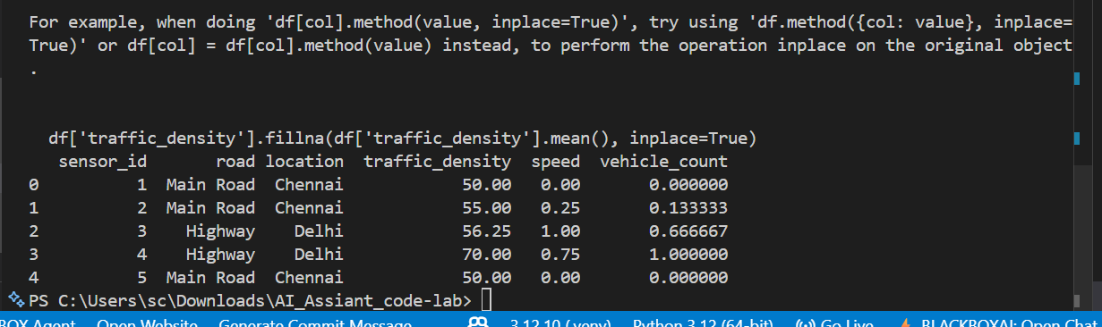

Observations:-
The traffic dataset was improved by standardizing road and location names, filling missing traffic density values, and removing duplicate records. Numerical features like speed and vehicle count were normalized, resulting in a cleaner and more consistent dataset with better overall quality.

Task 5 – (Social Media Text Data Cleaning and Feature Extraction)
• Task:
Use AI-assisted Python scripting to clean and preprocess social
media text data for sentiment analysis.
Instructions:
• Remove duplicate posts and null text entries.
• Clean text by removing URLs, special characters, and extra
spaces.
• Convert text to lowercase and perform basic tokenization.
• Remove stopwords and perform stemming or lemmatization.
• Generate basic text features such as word count and sentiment
score.
Sample Code:
import pandas as pd
import re
posts = pd.read_csv("social_media_posts.csv")
print(posts.head())
Expected Output:
A cleaned text dataset with extracted features suitable for sentiment
analysis models

Prompt:-
Clean text, remove duplicates/nulls, preprocess text, and extract features.

import pandas as pd
import re
from sklearn.feature_extraction.text import ENGLISH_STOP_WORDS

df = pd.read_csv(r"C:\Users\sc\Downloads\social_media_posts.csv")

df.dropna(subset=['text'], inplace=True)
df.drop_duplicates(subset=['text'], inplace=True)

def clean(text):
text = re.sub(r"http\S+", "", text)
text = re.sub(r"[^a-zA-Z ]", "", text)
text = text.lower()
words = text.split()
words = [w for w in words if w not in ENGLISH_STOP_WORDS]
return " ".join(words)

df['clean_text'] = df['text'].apply(clean)
df['word_count'] = df['clean_text'].apply(lambda x: len(x.split()))

print(df.head())

Output:-
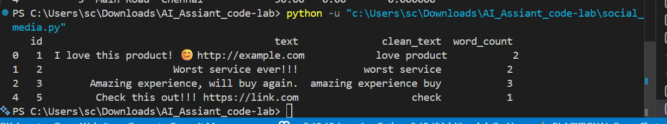

Observations:-
The social media dataset was cleaned by removing duplicate and null entries. Text data was processed by eliminating URLs, special characters, and extra spaces, followed by converting to lowercase and removing stopwords. Additional features such as word count were generated, making the data suitable for sentiment analysis.

